Name: Gandhi Meet Vipul

PRN No: 2020BTECS00112

**High Performance Computing Lab**

**Practical No. 8**

**Title of practical:** Implementation of Vector-Vector addition & N-Body Simulator using CUDA C

**Problem Statement 1:**

Implement Vector-Vector addition using CUDA C. State and justify the speedup using different size of threads and blocks.

**Screenshots:**

1. <<<1,1>>>

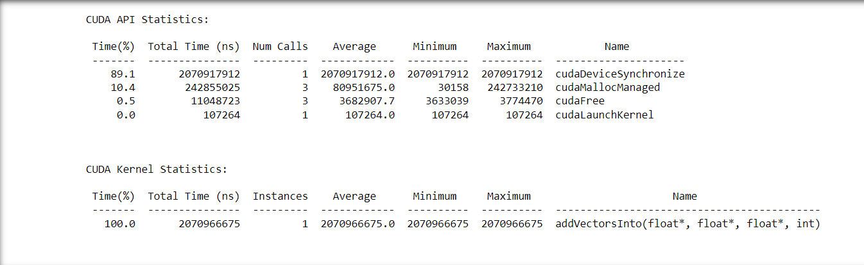

1. <<<1,64>>>

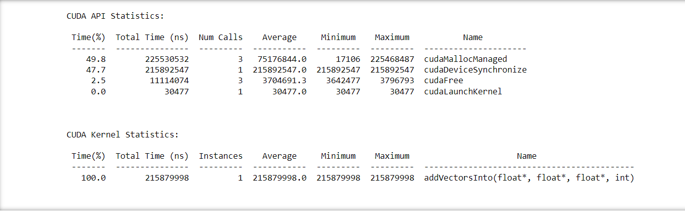

1. <<<1,128>>>

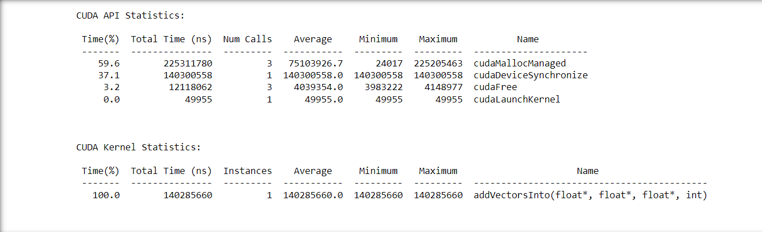

1. <<<2,64>>>

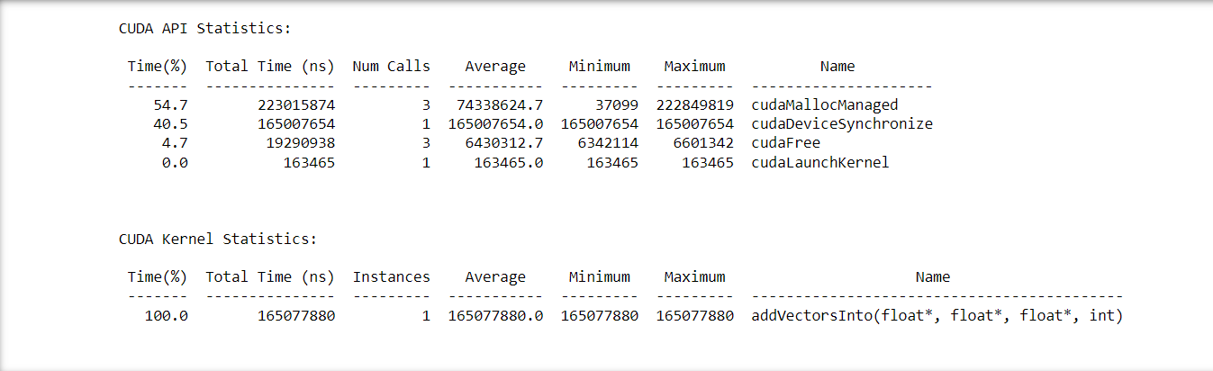

1. <<<2,128>>>

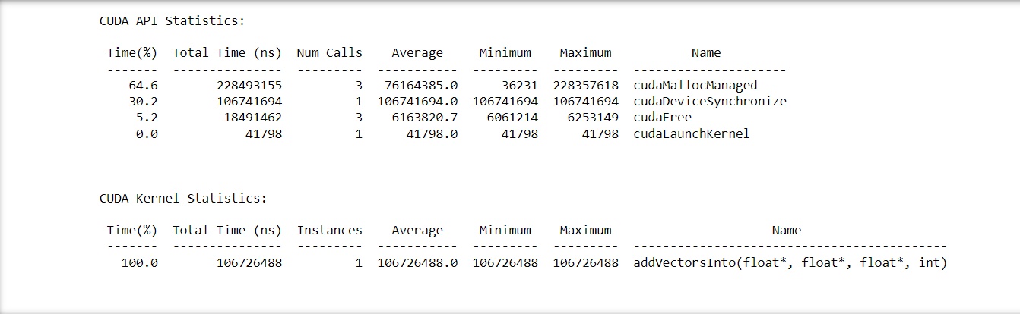

1. <<<4,64>>>

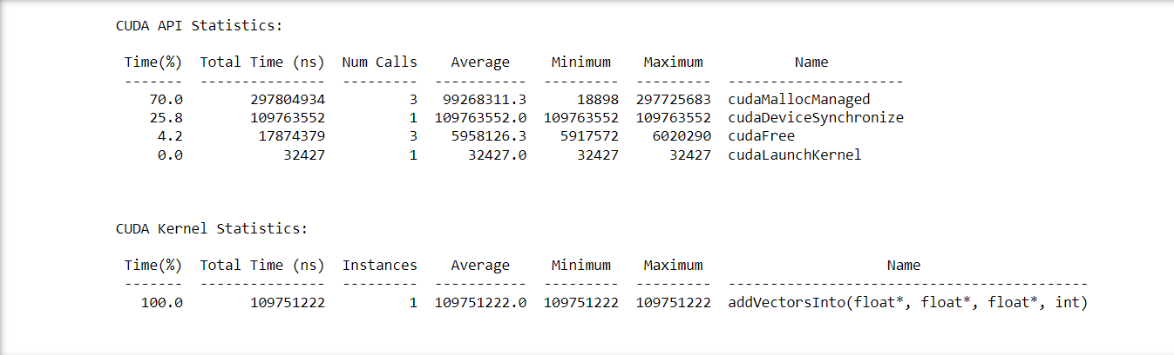

**Output:**



**Problem Statement 2:**

Implement N-Body Simulator using CUDA C. State and justify the speedup using different size of threads and blocks.

**Screenshots:**

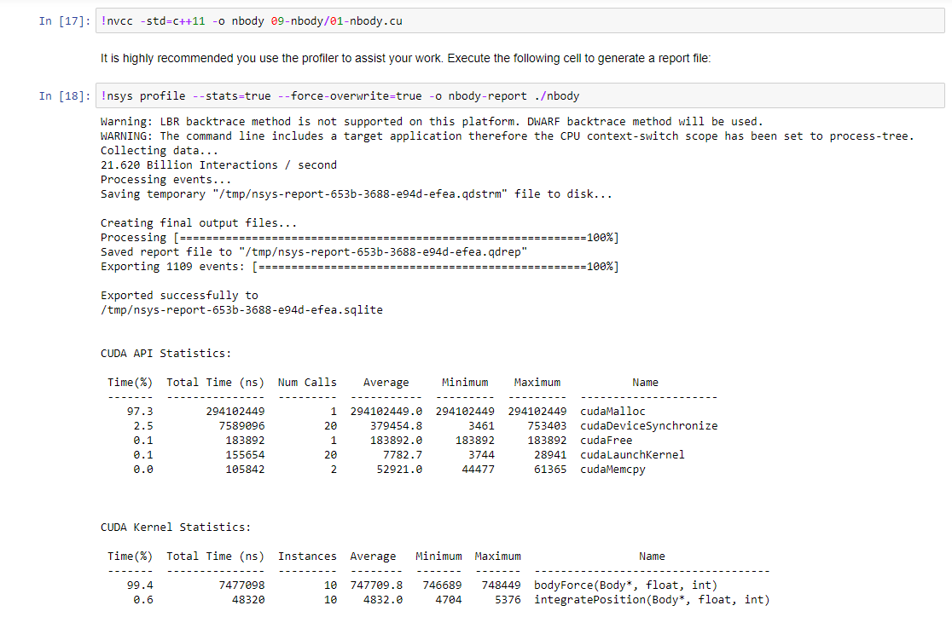

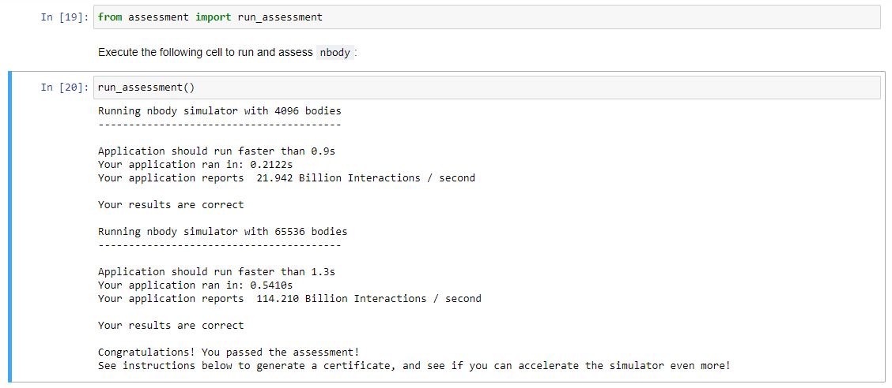 **Output:**

For 4096 bodies: 0.2122 secs

For 65536 bodies: 0.5410 secs